Valuation Calculation and Weights
🎥 This SOP has an accompanying video, which can be viewed here.

Weights

Purpose of Weights
The features of a property determine the property’s Assessed Annual Value (AAV). Think of the AAV as the price you would pay to rent a property for one year.

Examples of property features include Wall Material, Presence of Permanent Fence, Located in Central Business District, etc.

The amount that each property feature affects the AAV is known as the weight. It is helpful to think of weights in three categories:
- Surface Area Weight
- Property Feature Weights
- Structure Type Weight

A list of all the weights used in each council for the 2026 tax cycle can be accessed from the following links (permission restrictions applied by council):
Freetown
Kenema
Makeni

Surface Area Weight
The surface area weight is an adjustment to the property’s total surface area. Essentially, it reduces the value of each extra square foot of a building. The weight comes from a statistical formula based on Kenema property values and was established during the initial Kenema data analysis in 2023-2024.
In Kenema, the surface area weight is: $area^{0.75}$
So, if Property A has 100 square feet, the weighted surface area is: $100^{0.75}=31.6$
And if Property B has 10,000 square feet, the weighted surface area is: $10,000^{0.75}=1,000$
A keen observer will note that Property B is 100 times larger than Property A, but its weighted surface area is only 32 times larger. This is because the weight decreases the value of the extra area Property B to prevent it from being over-valued.

Property Feature Weights
The property feature weights are how much a property’s AAV changes when a property has that feature.

Example 1:
For example, in Kenema, the feature “Permanent Fence” has two options:
No: Weight = 0%
Yes: Weight = 15%
Let’s imagine a property with no fence that has an AAV of NLe 1,000. Now, imagine the owner built a fence around the property. This means the property value will increase by 15%. Represented mathematically: $1,000 + (1,000 × 15\%) = 1,000 + (150) = 1,150$
With the fence, the property AAV increases from NLe 1,000 to NLe 1,150.

Example 2:
Let’s try another example. This time, use the feature “Wall Material.” It has three options:
• Masonry (Concrete, Cement, Stone): Weight = 0%
• Mud-Based (Mud, Silveran, Wattle): Weight = -17%
• Zinc, Metal Sheeting, Wooden: Weight = -30%

Let’s imagine a property with cement walls that has an AAV of NLe 1,000.
If the owner magically changes the walls to become wattle, then the value of the property decreases by -17%. Mathematically: $1,000 +(1,000× -17\%) =1,000 + (-170) = 830$
The AAV changes from NLe 1,000 to NLe 830
And if you changed the walls from cement to zinc, the result would be:
$1,000 +(1,000× -30\%) =1,000 + (-300) = 700$
The AAV changes from NLe 1,000 to NLe 700

Structure Type Weight
The structure type weight works very similar to the property feature weights.
The statistical model used to estimate the AAV assumes that a property is a dwelling-style structure type. If the structure type is not a dwelling style, then a weight is used to adjust the AAV.

Some example of structure type weights in Kenema are:
Dwelling: Weight = 0%
Hotel: Weight = 70%
Bank: Weight = 106%

Example:
Let’s imagine a property with a dwelling structure type that has an AAV of NLe 1,000.
Now imagine a property with the same size and features, but with a hotel structure type. The value would be: $1,000 + (1,000× 70\%) = 1,000 + (700) = 1,700$
If it was a bank structure type instead, then the value would be: $1,000 + (1,000× 106\%) = 1,000 + (1060) = 2,060$

Note that the structure type weight is meant to reflect how a structure is built; it is not meant to reflect how a structure is used. So, for a property that was built as a dwelling but is now used as an office, it is better to select “House or Dwelling Style” since that is how the structure was designed.

The underlying theory of the structure type weight is that specific structure types cost different amounts to build on a per-square-foot basis. A bank has extra security features that increase its per-square-foot cost compared to a dwelling; a hotel must have extra plumbing and electrical fixtures compared to a normal dwelling – so each of these structure types have a structure type weight that increases their value. A storage building or industrial manufacturing structure type costs less per-square-foot to build, so they have a negative weight that reduces their AAV.

When answering the “property type”, you should ask, “how was this property designed when it was built?” And if it is not a dwelling, then ask, “How much more or less valuable is this property compared to a dwelling with the same size and features?”

Using Marshall units to get structure type weights
Most of the structure type weights in Moptax are based on Marshall units. Marshall units are an international standard for estimating construction costs of different buildings. A copy of a Marshall units reference document is here.

In that document, you will see on page 48 that a “single-family residence” in “fair” has a Marshall unit value of 82.5 per square foot. In the property valuation model, a structure type with a weight of 0 indicates that it also is estimated to have a Marshall unit value of 82.5.

If a structure’s construction cost per square foot is different than a single-family residence, then you can use Marshall units to calculate the structure type weight that should be used.

Example 1:
An example of a different structure type is “mixed retail centers with office units” in “average” condition, which have a Marshall unit value of 93.
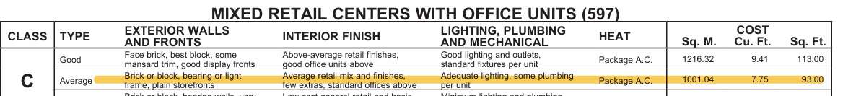

The equation below shows how we get the weight for the “mixed retail / office” structure type in Moptax:
$ratio = mixed retail office marshall units / single family residence marshall units$
$=93 / 82.5$
$=1.13$
Converting from a ratio to a percentage weight
$percentage weight = (ratio-1) ×100$
$= (1.13 -1) ×100$
$=13\%$
In Moptax, mixed retail / office structures have a weight of 13%.

Example 2:
An example of a different structure type is “cold stage facilities” in “average” condition, which have a Marshall unit value of 68.

The equation below shows how we get the weight for the “cool room” structure type in Moptax:
$ratio = cold storage marshall units / single family residence marshall units$
$=68 / 82.5$
$=0.82$
Converting from a ratio to a percentage weight
$percentage weight = (ratio-1) ×100$
$= (0.82-1) ×100$
$= -18\%$
In Moptax, cool rooms have a weight of -18%.

Base Value
The final component of the AAV formula to understand is the base value. The base value should be the same for all properties in your database.

The definition of the base value is the value per square foot of a property if the surface area weight was 1 and all the feature weights and structure type weights were 0.

Let’s imagine a property with 100 square feet. Let’s also imagine we have the surface weight set to 1 and all the feature and structure type weights at 0. If the Base Value is 15, then: $AAV = 15 ×100 = 1500$

It’s important not to think of the base value as the value per square foot. As mentioned in the “surface area weight section” above, when you use any surface area weight other than 1, each additional square foot of a property goes down in value.

The only time you should change the base value is to adjust for inflation
More on adjusting for inflation in the adjusting valuation and weights section

Finding base value and weights in Moptax
There are two primary areas you’ll notice the base value and weights for a property in Moptax: the “Measure” and “Features” tabs.

Let’s first look at the Features tab. It has feature weights, structure type weights, and the weighted base value.
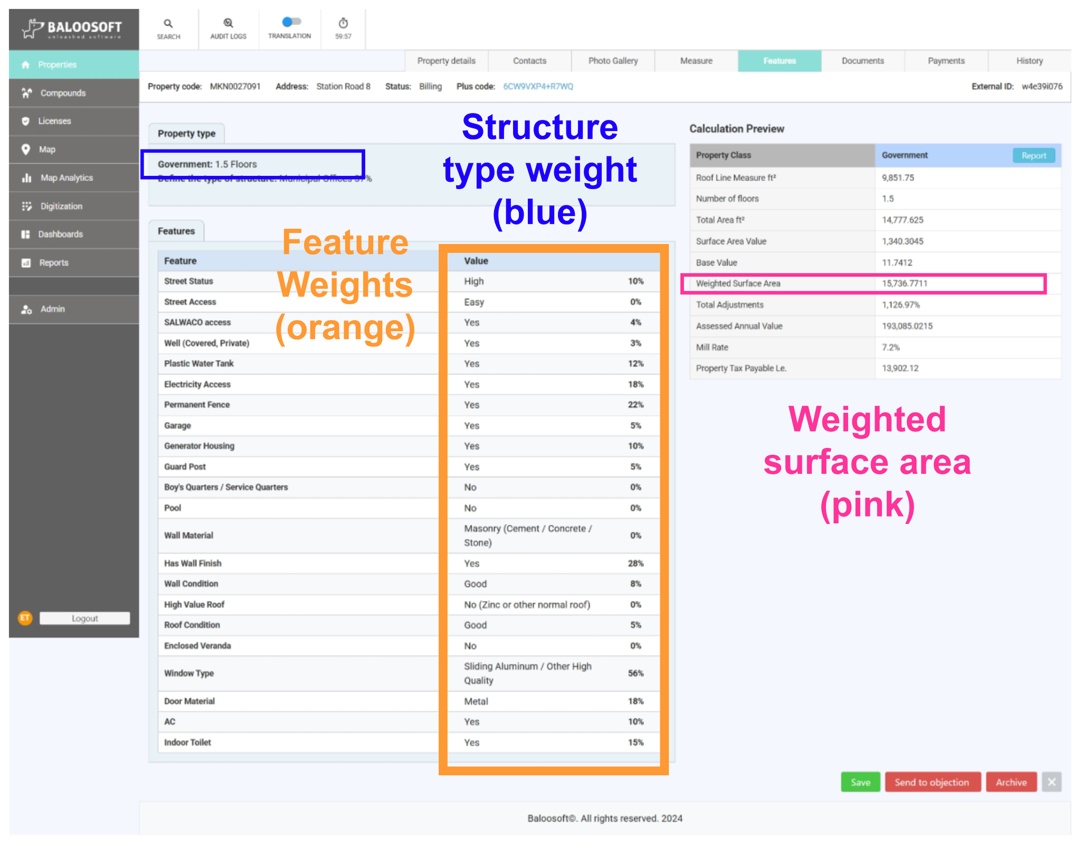
If you have feature weights that only apply to a specific property type (ex. “Parking Spaces on Property” for commercial, institutional, and NGO properties in Kenema), those features will appear in the “Property type” section of the “Features” tab
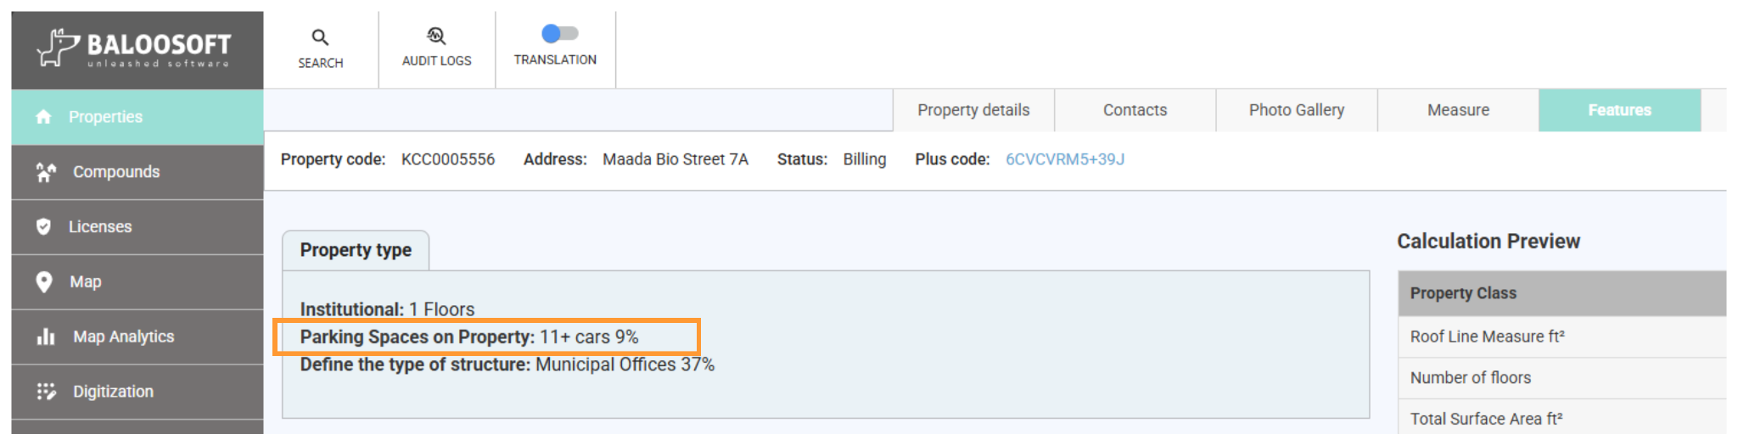

🚨Note that if you have location-based features, those values may be located on the “Measure” tab.
Any GIS layer that affects the value of a property has a symbol that looks like For example, in Makeni, there is a “Central Business District” layer and a “Low Community” layer that both have property feature weights. In the screenshot below, you can see how the Makeni City Council building has a 15% weight from being in the Central Business District.
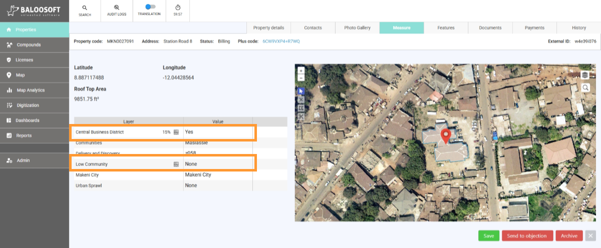

The other place to find the base value and feature weights in Moptax is in the “Forms” and “GIS Layers” sections of the Admin panel. We’ll talk about this in the adjusting valuation and weights section.

Calculating AAV
Now that we have the base value and weights, we have the components of the formula that we need to calculate the assessed annual value of a property. The formula follows the process in Figure 2.3.1.

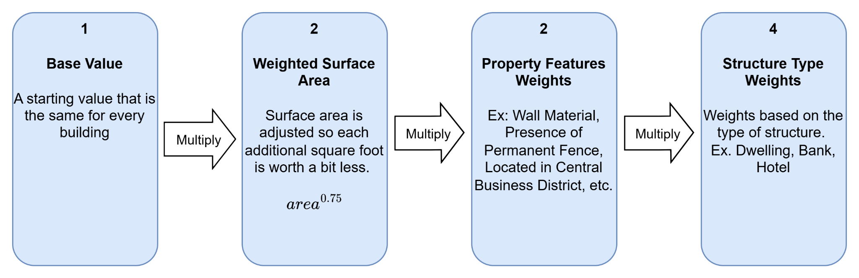
Figure 2.3.1: Process for Calculating Assessed Annual Value

To show how the formula works, let’s use an example :the Makeni City Council building. We can find all the information we need on the “Measure” and “Features” tabs.
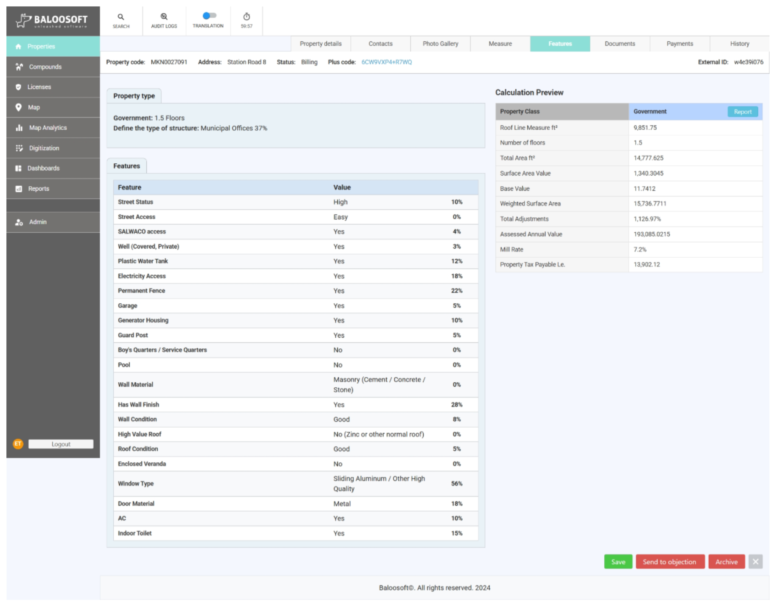
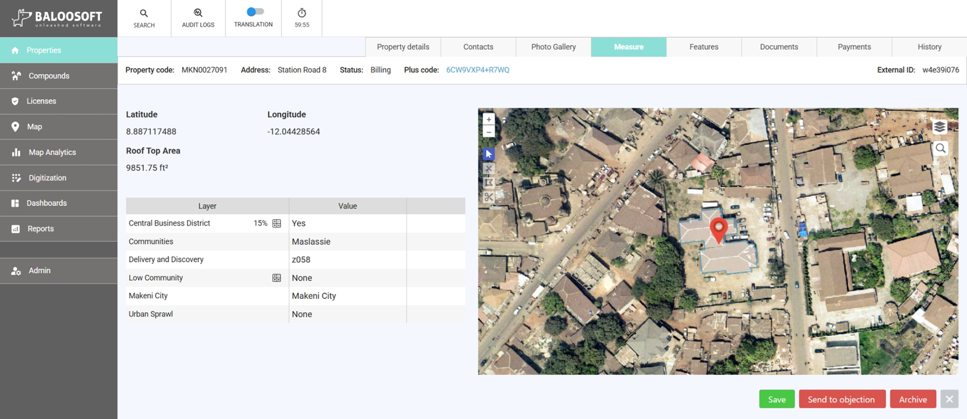

In the “Calculation Preview” section of the “Features” tab, we first get the base value:
$Base value = 11.7412$

Second, we get the weighted surface area:
$Weighted Surface Area =1,340.3045$

If you want to understand how the weighted surface area was calculated, look at the “bonus” below.

Bonus: Calculating Weighted Surface Area
Moptax provides you not only with the weighted surface area, but also the components of the equation to get the result yourself. You just need to understand the following formulas:

$Total Area=Roof Line Measure × Number of Floors$
$Weighted Surface Area = Total Area^{Surface area weight}$

In our Makeni City Council building example:
$Total Area=Roof Line Measure × Number of Floors=9,851.75×1.5=14,777.625$
$Weighted Surface Area = Total Area^{Surface area weight}=14,777.625^{0.75}=1,340.3045$

Third, we’ll get the feature weights. Moptax doesn’t directly give us the combined feature weights, but we can calculate it ourselves.
The only complicated aspect is converting the percentage weight, to a decimal proportion. To make the conversion you use this formula:
$decimal proportion weight = (percentage weight ÷ 100)+1$

Example 1: Street Status: High = 10%
$decimal proportion weight = (percentage weight ÷ 100)+1=$
$=(10 ÷ 100)+1$
$= 0.1 +1$
$= 1.1$

Example 2: Difficult Access: Yes = -13%
$decimal proportion weight = (percentage weight ÷ 100)+1=$
$=(-13 ÷ 100)+1$
$= -0.13 +1$
$= 0.87$

Feature | Weight (%) | Weight (Decimal Proportion)
Street Status: High | 10% | 1.10
SALWACO access: Yes | 4% | 1.04
Well (Covered, Private): Yes | 3% | 1.03
Plastic Water Tank: Yes | 12% | 1.12
Electricity Access: Yes | 18% | 1.18
Permanent Fence: Yes | 22% | 1.22
Garage: Yes | 5% | 1.05
Generator Housing: Yes | 10% | 1.10
Guard Post: Yes | 5% | 1.05
Has Wall Finish: Yes | 28% | 1.28
Wall Condition: Good | 8% | 1.08
Roof Condition: Good | 5% | 1.05
Window Type: Sliding Aluminum / Other High Value | 56% | 1.56
Door Material: Metal | 18% | 1.18
AC: Yes | 10% | 1.10
Indoor Toilet: Yes | 15% | 1.15
Central Business District: Yes  This is in the “Measure” tab. Don’t forget to look there! | 15% | 1.15
Combined feature weights as decimal proportion |  | 8.956

Now, we need to multiply all the decimal proportion weights. The product is the combined weight of the features, expressed as a decimal proportion is 8.956

Fourth, we need the property type weight, and we need to convert it to a decimal proportion weight.
In the “Calculation preview” portion of the “Features” tab, we see that the structure type is “Municipal Offices” with a weight of 37%
$Property type weight decimal proportion = (percentage weight ÷ 100)+1$
$= (37 ÷ 100)+1$
$= 0.37+1$
$Property type weight decimal proportion= 1.37$

Bonus: Calculating Total Adjustments as Percent

In the “Calculation Preview” portion of the “Features” tab, Moptax provides a row called “Total Adjustments.”
The “Total Adjustments” row is the percent amount that the Surface Area Value will be adjusted based on the feature and structure type weights.

Up until now, we’ve calculated the combined feature weights as a proportion and the structure weights as a proportion. To get the total adjustment, we need to multiply both values:
$Total Adjustments decimal proportion = combined feature weights decimal proportion ×property type weight decimal proportion$
$= 8.956 × 1.37$
$=12.2697$

Then, we need to express this as a percentage instead of a decimal proportion:
$Total Adjustments percentage =( Total Adjustments decimal proportion -1) × 100$
$=( 12.2697 -1) × 100$
$=11.2697 × 100$
$=1,126.97 \%$

The result matches the value we see for “Total Adjustments” in Moptax.

Now, we have all the components we need:
$Base value = 11.7412$
$Weighted Surface Area =1,340.3045$
$Combined feature weights as decimal proportion = 8.956$
$Structure type weight as decimal proportion = 1.37$

Now, we just multiply these values together. The product is the AAV.

$AAV = base value × weighted surface area × combined feature weights as decimal proportion × structure type weight as decimal proportion$
$= 11.7412 ×1,340.3045×8.956×1.37$
$= 193,085.9235$

In the “Calculation Preview” in Moptax, we see the “Assessed Annual Value” is 193,085.0215. The difference of NLe 0.9 is simply due to differences in rounding. We successfully calculated the AAV of the property!

For a deeper look at the valuation formula, there is a comprehensive user manual for the point-based property tax valuation model written specifically for the Sierra Leone context and a guidance note by LoGRI on points-based valuation systems more broadly.

